POLAR AND ICE WATERS VOYAGE PLANNING
REVIEW OF RISK ASSESSMENTS FOR OPERATIONS IN POLAR AND ICE WATERS

Use this form for intended voyages in the polar areas (see diagrams below) or other areas where ice may be present.
Use this as a minimum checklist for the Risk Assessment (RA) required (by VMS sections Fleet Ops > 9.0 Safety Management > 9.2 Operational Risk Assessment “and Fleet Ops > 4.0 Marine Operations > 4.1 Navigational Operations > 4.1.21 Polar and other Ice Waters Voyages) – see Shipsure Generic Risk Assessment # 5 “Polar and Ice Operations”
For ships with a Polar Code Certificate issued - Use this form in conjunction with the limitations on the Certificate and the Polar Waters Operations Manual.

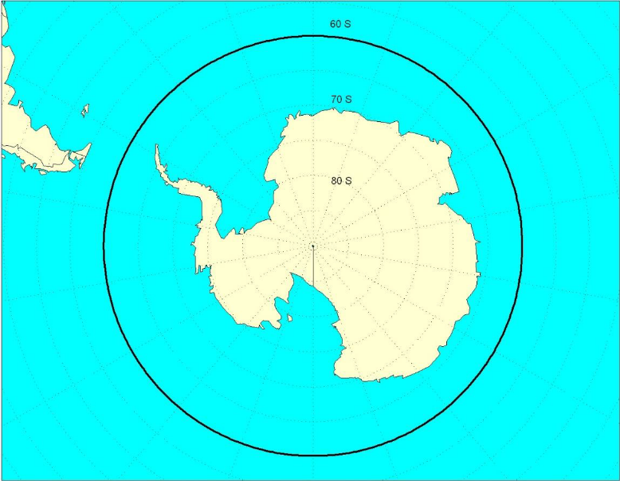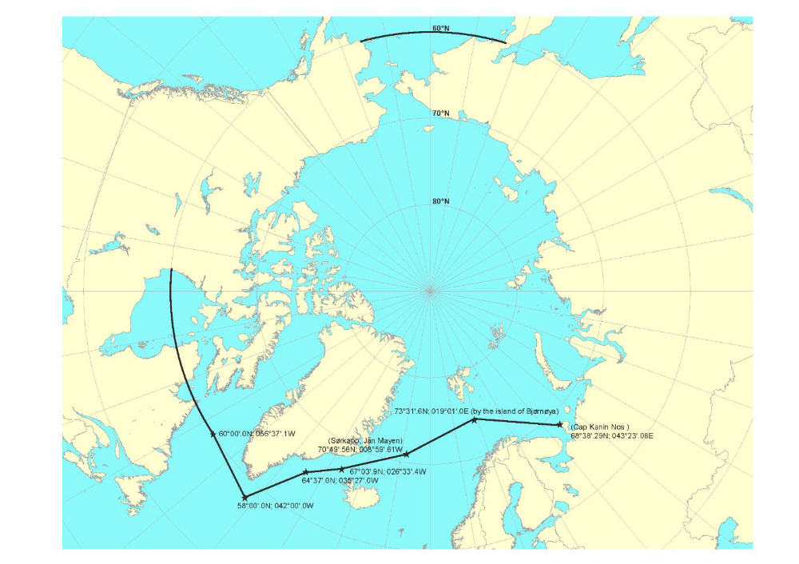

M/V |  | Initial Risk Assessment Review |  | Yes € No €  If Yes, date of Initial RA:
Summary of Ice Class  and Related Data |  |  | Polar Code certified | Yes € No €
Area of Polar (or Ice) Operations |  |  | If Polar Code certified – any Polar certificate and Polar Waters Manual limitations
Start date |  | End Date
Summary of the Polar Season
and Other Data anticipated for the Planned Voyage

Date of Review  (min two months before the intended voyage) : |  | Date of Voyage Execution: | Risk Assessments Amended Yes € No €  (If “YES” - details/reference in Remarks )
Master:  Name / Sign. |  | Master:  Name / Sign.
Staff Captain / Chief Officer:  Name / Sign. |  | Staff Captain / Chief Officer:  Name / Sign.
Chief Engineer:  Name / Sign. |  | Chief Engineer:  Name / Sign.

DPA Reviews  Dates: |  | DPA  Name / Sign.
DPA Comments

HAZARD (per Polar Code, Introduction part 3)  and related aspects with controls for consideration | Risk Assessed and  Tolerable? | Outstanding Actions / Mitigation / Remarks
- ICE
as it may affect hull structure, stability characteristics, machinery systems, navigation, the outdoor working environment, maintenance and emergency preparedness tasks and malfunction of safety equipment and systems
- NAVIGATION:
- Subscription to Weather and Ice information service?
- Ice detection radar available?
- [other]
- NAVIGATIONAL EQUIPMENT
- Conning Position vision enhancing equipment: de-icers, de-misters, windows cleaners, anti-glare equipment?
- Equipment for receipt of ice information operational?
- [other]
- MACHINERY SYSTEMS/EQUIPMENT
- Deck Machinery (windlasses, winches, cranes) checked – greased, suitable hydraulic oil, el. motors protected?
- Anchoring and towing arrangement checked: bollards free, rollers greased and turning, mooring ropes protected?
- Scuppers clear and dry?
- WTDs and watertight hatches checked and closed before entry into ice waters?
- Propulsion systems, auxiliaries, electrical, heating, ventilation systems checked and prepared for operation in ice conditions?
- Environmental Equipment (sewage treatment plant, OWS (not allowed to be used > 60 deg S lat), incinerator) checked and prepared for operation in ice conditions?
- [other]
- CREW TRAINING FOR EMERGENCY PREPAREDNESS
- Emergency procedures (ie Muster, Survival Craft launching, Fire, Abandon Ship, MOB, Damage Control) reviewed and deviations from standard procedures due to ice and cold temperatures identified, highlighted to responsible personnel and passed to DPA for inclusion in the Master’s Decision Support System ?
- Emergency Drills Plan in place to take into account ice operating conditions?
- Monthly Rescue Boat drills with assigned operating crew in ice conditions?
- Relevant crew familiar with the Damage Control Plan: WTDs and hatches to be kept closed, damage control valve operation, stability calculations?
- [other]
- EMERGENCY EQUIPMENT - LSA
- Emergency lighting checked and prepared for operation in ice conditions
- [other]
- EMERGENCY EQUIPMENT – VARIOUS
- Public address system audible on open decks under ice (breaking) conditions?
- [other]
- Experiencing topside icing,
with potential reduction of stability and equipment functionality;
- STABILITY
- Stability Manual / software has data for / capable of assessing and calculating ice accretion (accumulation of ice on deck and equipment due to sea spay, rain or snow freezing)?
- Weather forecast (wind speed, air temperature, precipitation) indicate likelihood of ice accretion?
- Stability with ice accretion within limits / with reserve?
- [other]
- CREW TRAINING FOR EMERGENCY PREPAREDNESS
- Fire drills scenarios planned with ship in iced conditions?
- [other]
- EMERGENCY EQUIPMENT - FFE
- Exposed fire dampers and ventilation covers checked and greased or otherwise prepared for closing in iced conditions
- [other]
- EMERGENCY EQUIPMENT - FFE
- Suitable Ice removal equipment (ie ice mallets) available at survival craft?
- [other]
- EMERGENCY EQUIPMENT - VARIOUS
- Provisions to keep escape routes on open decks clear from ice and snow?
- [other]
- LOW TEMPERATURE,
as it affects the working environment and human performance, maintenance and emergency preparedness tasks, material properties and equipment efficiency, survival time and performance of safety equipment and systems;
- NAVIGATIONAL EQUIPMENT
- Considerations to prevent Radar Scanners and Whistle from freezing?
- Search lights remotely controlled close to conning position? (see also local requirements for Greenland at the end of the form)
- [other]
- MACHINERY EQUIPMENT / SYSTEMS
- Exposed water and steam piping: protected or dry?
- Consideration given to water containing tanks (Potable/ Ballast / Grey / Black) freezing?
- Supplies and adequate reserve of suitable low temperature fuels and oils?
- Engines cooling systems (anti-freeze, temperature control), sea chests (steam injection)
- [other]
- EMERGENCY EQUIPMENT – FFE
- Fire main system checked: piping, pumps, suctions, isolating valves, hydrants
- Fire main system external sections arranged so that possible to isolate and drain?
- Exposed water/foam containing equipment (ie. portable extinguishers): checked and protected or relocated?
- At least one spare fire fighter outfit stored in an easily accessible warm location?
- [other]
- EMERGENCY EQUIPMENT – LSA
- Additional immersions suits and/or thermo protective or insulating protective clothing considered?
- Personal and Group Survival Kits (PSK / GSK) considered?
- Training units of PSK and GSK considered and available?
- Open and/or Partially Enclosed lifeboats carrying tarpaulins and supports to provide complete coverage?
- Life/rescue boats starting/charging batteries protected and secured?
- Life/rescue boats engines have means to start readily in low temperatures (incl. low temp. fuel)?
- Drinking water protected and storage containers allow for expansion if frozen?
- Additional inflation pumps carried out for life rafts and stored in warm location nearby?
- [other]
- extended periods of darkness or daylight,
as it may affect navigation and human performance
- NAVIGATION
- Search lights and visual signal checked and available?
- Bridge Windows have dark shades (for daylight)
- Bridge watch team use sunglasses that minimize glare (i.e. polarized)
- [other]
- NAVIGATIONAL EQUIPMENT
- All equipment illumination in working condition under any operational conditions?
- Night vision / ice detection camera available (for periods of darkness)?
- [other]
- HUMAN ELEMENT
- Crew provided with sufficient rest hours in comfortable conditions (dark and quiet cabin)?
- Crew watch pattern adjusted to minimize cold weather exposure, fatigue, underperformance?
- [other]
- HIGH LATITUDE,
as it affects navigation systems, communication systems and the quality of ice imagery information
- NAVIGATION
- Gyro compass(es) serviced within the last year?
- Two Gyro Compasses available?
- Magnetic Compass working well (recent deviation established) and corrections frequently checked and recorded?
- Satellite Navigations system available and working well?
- GNSS: GPS and/or GLONASS? More than one receiver?
- GNSS can be used as a satellite navigation compass?
- [other]
- NAVIGATIONAL/COMMUNICATION EQUIPMENT
- GMDSS area A4 equipment available?
- Second means/subscription for receiving weather and ice imagery information (not affected by high latitude signal reception)?
- [other]
- REMOTENESS,
and possible lack of accurate and complete hydrographic data and information, reduced availability of navigational aids and seamarks with increased potential for groundings compounded by remoteness;
limited readily deployable SAR facilities, delays in emergency response and limited communications capability, with the potential to affect incident response
- NAVIGATION
- Adequate and up to date navigational information (charts and publications, including those for ice operations available?
- Position indicating service to a chart plotting facility ashore available or subscribed to?
- [other]
- NAVIGATIONAL EQUIPMENT
- Radar Installations checked and working well? More than two?
- Depth sounding Device checked and operational? Sufficient Paper?
- ECDIS available? (If area covered by Raster Charts – paper back up charts required)
- AIS checked and operational?
- Speed and Distance measurement device checked and working well?
- Rudder angle indicator checked and operational?
- Voyage Data Recorder checked and operational
- [other]
- SAR
- Ship’s itinerary and position reporting system available to RCC? (see also mandatory reporting system for Greenland at the end of the form)
- Other passenger ships available in the area? Positions tracked and exchanged (for IAATO and AECO areas – vessel tracker (aka RedPort tracker) installed and subscription in place)? (see also specific local requirments for Greenland for use of ArcticWeb platform at the end of this form)
- Vessel assigned with Emergency Response Service (ERS) Ashore for damage stability? Last Emergency Drill?
- [other]
- potential lack of ship crew experience in polar operations,
with potential for human error
- NAVIGATION
- Officers from the Bridge and Engine Teams with ice training (Company specific - per Company Training Pack and/or STCW – state if transitional STCW B-V/g)?
- Officers from the Bridge and Engine Teams with ice experience available?
- Use of Ice Pilot considered? (see local requirements for Greenland and Svalbard at the end of the form)
- Adequate number of PECs (Pilot Exemption Certificate) on board? (see local requirements for Svalbard at the end of the form)
- [other]
- potential lack of suitable emergency response equipment,
with the potential for limiting the effectiveness of mitigation measures;
- EMERGENCY EQUIPMENT – DAMAGE CONTROL EQUIPMENT
- Sufficient materials to carry out temporary minor hull breach repairs and to take measures preventing flooding and escalating of damage?
- Weekly damage control drills considering Fleet Ops > 4.0 Marine Operations > 4.1 Navigational Operations > 4.1.21 Polar and other Ice Waters Voyages > Crew polar training
- [other]
- EMERGENCY EQUIPMENT – VARIOUS
- Medical onboard supplies, equipment and facilities adequate?
- Sufficient spill cleanup & absorbent materials & equipment available?
- Additional equipment required for RIBs/zodiacs of less than 24m carrying less than 12 pax in Norway/Svalbard (https://bit.ly/svalbard_zodiacs_equipment and https://www.sdir.no/en/shipping/legislation/directives/alternative-to-one-piece-flotation-suits-for-vessels-carrying-12-passengers-or-less-from-a-mother-ship/)
- [other]
- rapidly changing and severe weather conditions,
with the potential for escalation of incidents;
- NAVIGATIONAL EQUIPMENT
- Equipment for receipt of weather information operational?
- Duplicated means/subscription for receiving weather and ice imagery information
- [other]
- SAR
- Responsible RCC for the Area identified and advised of the ship’s arrival?
- Ship’s Data Provider advised to RCC and Emergency Plans, ship’s SAR plan, ECP-SOPEP and drawings sent as requested. (see also specific local requirements for Greenland at the end of the form)
- SAR drill performed with RCC and Head Office?
- [other]
- EMERGENCY EQUIPMENT - LSA
- Extra life rafts considered in lieu of open lifeboats for emergency preparedness?
- [other]
- CREW TRAINING FOR EMERGENCY PREPAREDNESS
- Vessel assigned with Emergency Response Service (ERS) Ashore for damage stability? Last Emergency Drill?
- Abandon Drills panned with additional scenarios for evacuation on ice, water or combination of both?
- [other]
- Environment,
with respect to sensitivity to harmful substances and other environmental impacts and its need for longer restoration
- MACHINERY EQUIPMENT/SYSTEMS
- No residual/ heavy fuel oil carried onboard (as applicable for the itinerary, reference SAF77)
- Sufficient waste holding capacities (bilge water, sludge, sewage, garbage incl. food waste – reference SAF77 and VMS section Garbage Management Plan)
- Specific certifications needed (Canadian Arctic Oil Pollution Prevention Certificate)
- Environmentally acceptable oils in Oil to Sea Interface Systems?
- [other]
- WASTE MANAGEMENT
- Antarctica (Initial Environmental Assessment) see SAF77
- No carriage onboard of specific food products (Discharge of introduced avian products, including poultry and poultry parts, is not permitted in the Antarctic area unless it has been treated to be made sterile)
- [other]
- WILDLIFE PROTECTION
- Awareness and Observance of IAATOs and AECOs environmental/visits/wildlife guidelines
- Firearms for protection of wildlife – qualifications, licenses, secure storage
- [other]

Additional / Local Requirements:

Place | Navigation / Ice Class | Qualification / Training / Certification | Safety / Contingency | Environmental | Further references
Greenland | ALL SHIPS:  Navigation requirements:  - in areas where depths are given by a single sounding line:  - navigate with enhanced for unknown sub-marine obstacles  - consider such sounding lines merely as reconnaissance  - in darkness- have onboard and use ice searchlights to light up the sea in front of the ship  - in areas delimited in the chart by a dotted line with infor-mation about “talrige skær/numerous rocks” - navigation is prohibited  - in areas given on the chart as “urent område/foul” or “uopmålt/unsurveyed” - navigate only if you follow previously used tracks that the master has assessed as safe;  OR  if you take appropriate safety measures:  - determine position by means of terrestrial and/or radar navigation  - voyage only in daylight and in "good visibility",  - proceed only at the speed necessary to keep manoeuvrability,  - sound waters ahead to the extent possible  - around Nuuk - follow the recommended routes  Structural / Ice Class requirements:  - Navigate in ice only if the ship is structurally designed for operation in the relevant types and concentrations of ice  - Have ice class:  - corresponding, as a minimum, to the ice you are navigating  - in the northern navigation zone* -minimum Baltic ice class 1C or an equivalent ice class.  - in "open waters" or "no sea ice" in the southern navigation zone* - no ice class required | ALL SHIPS:  - have at least one person available on board with the necessary local knowledge of the waters to be navigated and about navigation in arctic and icy waters  SHIPS CARRYING >250 PAX:  - in the inner and outer territorial waters around Greenland:  - take a pilot certified to perform pilotage assignments in the area concerned  OR  - have another person onboard with the necessary qualifications and experience in navigating the waters concerned  - educate and train the ship's master and deck officers ( per part B-V/g of the STCW Code) before commencing OR  consider at least three months' documented seagoing service as a navigating officer in polar waters under similar ice conditions equal to such an education and training programme | ALL SHIPS:  - Include only enclosed (or semi-enclosed) lifeboats in the ship’s emergency preparedness equipment  - Have procedures and contingency plans that take account of the special conditions related to navigation in arctic waters, including the search and rescue preparedness available  SHIPS CARRYING >250 PAX:  - have contingency and [the ship’s] SAR plan taking special account of the number of persons on board as well as the period to be expected before being assisted in case of an accident.  - Include in the contingency and [the ship’s] SAR plan agreements on cooperation with the rescue service in the area  - document that it would be possible to be assisted by other ships or SAR facilities within a reasonable period of time and with sufficient rescue capacity [see:  https://arcticweb.e-navigation.net/ ]  - ensure that an overall assessment of the risks that the ship is expected to meet during the voyage is made on an ongoing basis onboard | Reference SAF77 | http://www.dma.dk/SikkerhedTilSoes/Arktis/SejladsGroenland/Sider/default.aspx  Order 1697 for Greenland on the safe navigation, etc. of ships: http://bit.ly/2oBJkR2  Order 1698 on pilotage, etc. around Greenland  http://bit.ly/2nT5QGQ  Order 1699 on the activities of pilotage service providers and the obligations of pilots in Greenland  http://bit.ly/2otUURb  *The two navigation zones extend to 3 nautical miles from the base line and cover the inner and outer territorial waters around Greenland:  a. The northern navigation zone extends from north of Tasiilaq (66º N) on the east coast of Greenland, north of Greenland, to north of Upernavik (72º N) on the west coast of Greenland  b. The southern navigation zone extends from north of Tasiilaq (66º N) on the east coast of Greenland, south of Greenland, to north of Upernavik (72º N) on the west coast of Greenland
Svalbard |  | PEC can be used onboard passengers ships in Svalbard waters with Length overall (LOA) between 50 and 150 meters (though some can be also issued above 150m)  there are three classes of PECs  - Class 3 for vessels less than 100m LOA equipped with an ECDIS – valid for 5 years  - Class 2 for vessels between 100 and 150m – valid for 5 years  - Class 1 for vessels (exceptionally) above 150m – valid for 2 years  All can be renewed provided the applicant has maintained knowledge of the waters the PEC has been issued for (or in a simulator) |  | Reference SAF77 carriage of residual / heavy fuel oil not allowed) | Norwegian Regulations on compulsory pilotage and the use of pilot exemption certificates (Compulsory Pilotage Regulations): https://www.kystverket.no/globalassets/ohm-regelverk/engelsk/02.2021_compulsory-pilotage-regulations.pdf
Arctic and Antarctica – AECO and IAATO members |  |  |  | Sites, visitors, biosecurity and wildlife watching guidelines | http://www.aeco.no/guidelines/  http://iaato.org/guidelines-and-resources

